**Differences in Sex on Weight Change’s Effect on Cholesterol**

1/26/2024, Kath Fillman

**Introduction.**  A four year randomized clinical trial focused on the efficacy of nonpharmacologic approaches for the treatment of stage 1 hypertension that used a lifestyle intervention program and drug therapy to gather data on the effects of weight loss on participant's indicators of health, including cholesterol levels. This analysis aimed to ascertain if sex is a confounding factor in the effect of weight change on cholesterol change.

**Dataset.** The dataset tomhs.csv was provided by the instructor. It contained data from 902 participants(234 placebo, 668 treatment) in 126 categories including the clinic they were treated at, study group, age at beginning of study, sex, race, smoking status, weight, blood pressure, total cholesterol, and blood glucose.

**Exploratory Data Analysis.** Variables of interest (change in weight and cholesterol) were calculated by subtracting the subject’s baseline measurements(wtbl/cholbl) from their measurements at the 1 year mark (wt12/chol12).Change in weight had a range of -46.75 lbs to 18.5 lbs with a mean of -10.52l bs with a standard deviation of 9.4 lbs (table 1). A histogram depicting the distribution of weight change (fig. 1) visualized a -0.62 left skew. Change in cholesterol had a range of -141 mg/dL to 117 mg/dL with a mean of -7.22 mg/dL and a standard deviation of 25.85 mg/dL(table 1). A histogram visualizing change in cholesterol (fig, 2) shows a -0.15 left skew. The distribution of sex in this dataset is very uneven, with about 62% of participants being males (table 2).

The relationship between change in weight and change in cholesterol seems to be approximately linear with no significant outliers to speak of (fig. 3).

**Methods.** The association between change in weight and change in height while controlling for sex was investigated using multiple linear regression. The association was summarized using the slope of the line. Both an unadjusted model and a model adjusted for sex were considered. P-values less than 0.05 were significant. All analyses were performed in R-studio version 2023.12.0, build 369.

**Results.** The results of the multiple linear regression analyses, both unadjusted and adjusted for sex, are shown in table 3. The unadjusted slope is 0.5456 and the adjusted slope is slightly less steep at 0.5169; both slopes are statistically significant (p<0.0001). The unadjusted intercept is -1.4402 and the adjusted intercept for men is -2.8319 and 0.0370 for females. The adjusted R2 value for the unadjusted model is 0.0381 and slightly higher at 0.0396 for the adjusted model.

**Conclusions.** In this study, sex is a confounding factor in the relationship between weight change and change in cholesterol. Cholesterol increases 0.5169 mg/dL for every pound that is gained, after adjusting for sex.

**Appendix.**

**Table 1. Summary Statistics**

|  | **Change in Weight** | **Change in Cholesterol** |
| --- | --- | --- |
| **Minimum** | -46.75 | -141 |
| **Maximum** | 18.5 | 117 |
| **Mean** | -10.52 | -7.22 |
| **Trimmed Mean** | -9.95 | -6.84 |
| **Standard Deviation (sd)** | 9.4 | 25.85 |
| **Skew** | -0.62 | -0.15 |

**Table 2. Proportions of Sex**

|  | **N** | **Proportion** |
| --- | --- | --- |
| **Male** | 557 | 0.6175166 |
| **Female** | 345 | 0.3824834 |

**Table 3. Model Summary**

| **Unadjusted Model** | | | | | |
| --- | --- | --- | --- | --- | --- |
|  | **Slope** | **Intercept** | **95% CI** | **p-value** | **Adjusted R2** |
|  | 0.5456 | -1.4402 | 0.3629, 0.7283 | <0.0001 | 0.0381 |
| **Adjusted Model** | | | | | |
|  | **Slope** | **Intercept** | **95% CI** | **p-value** | **Adjusted R2** |
| **Males** | 0.5169 | -2.8319 | -5.9642, 0.3004 | <0.0001 | 0.0396 |
| **Females** | 0.0370 | -0.7926, 6.3823 | 0.1266 |

**Figure 1.**

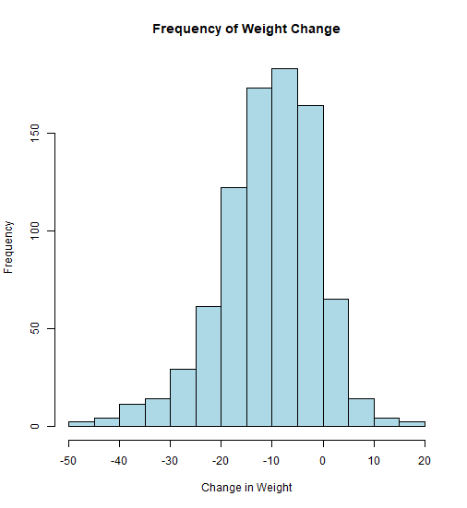

**Figure 2.**

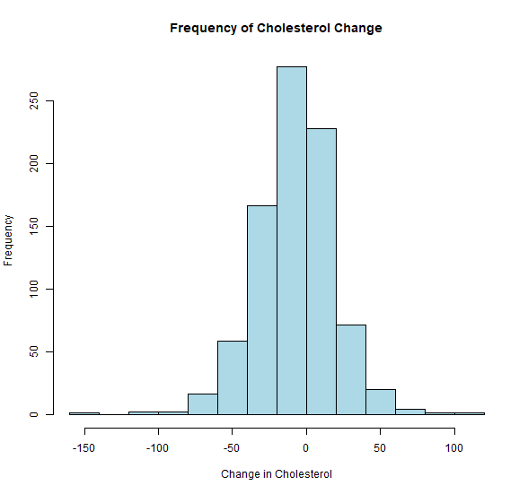

**Figure 3.**

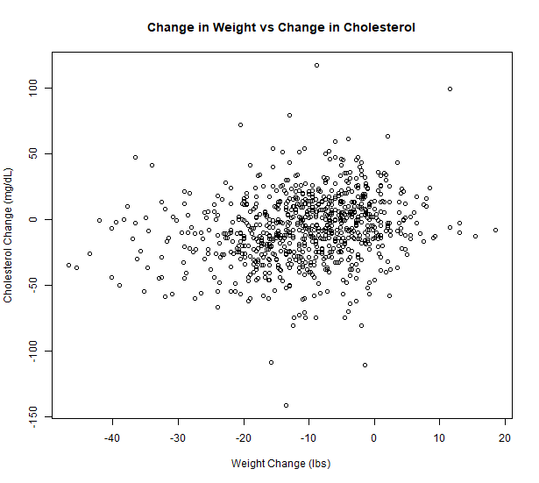

**Figure 4.**

